**Design Logic App Api and complete configuration as shown**

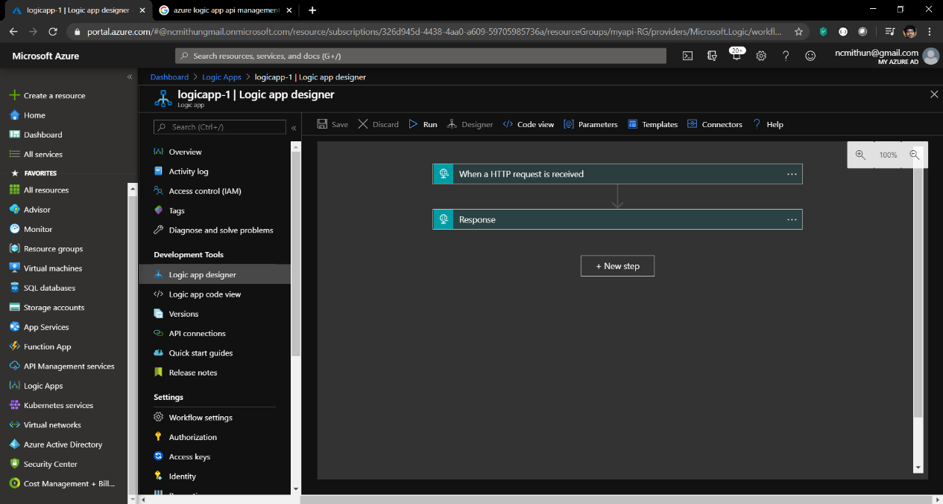

Complete the logic app design as required

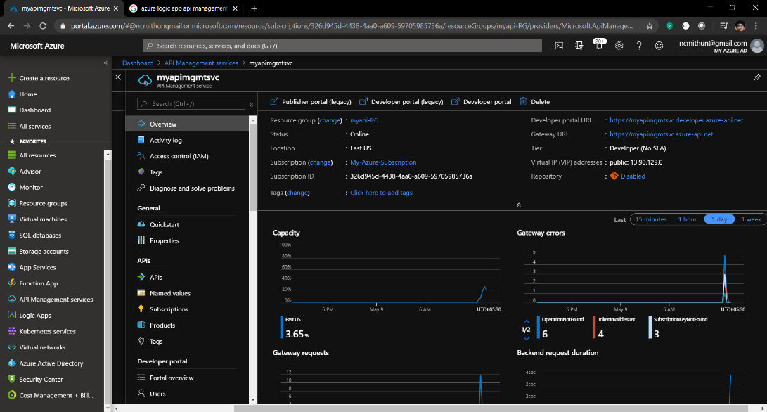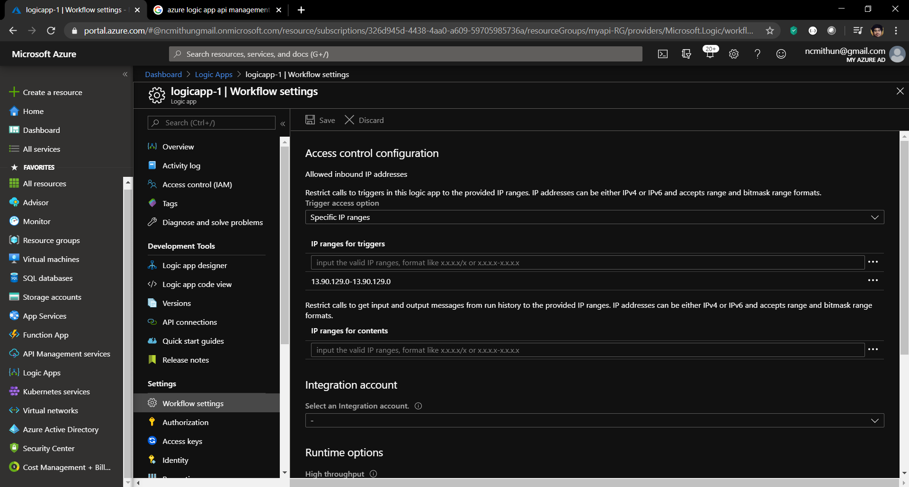

**Test Logic app api directly to ensure no direct access**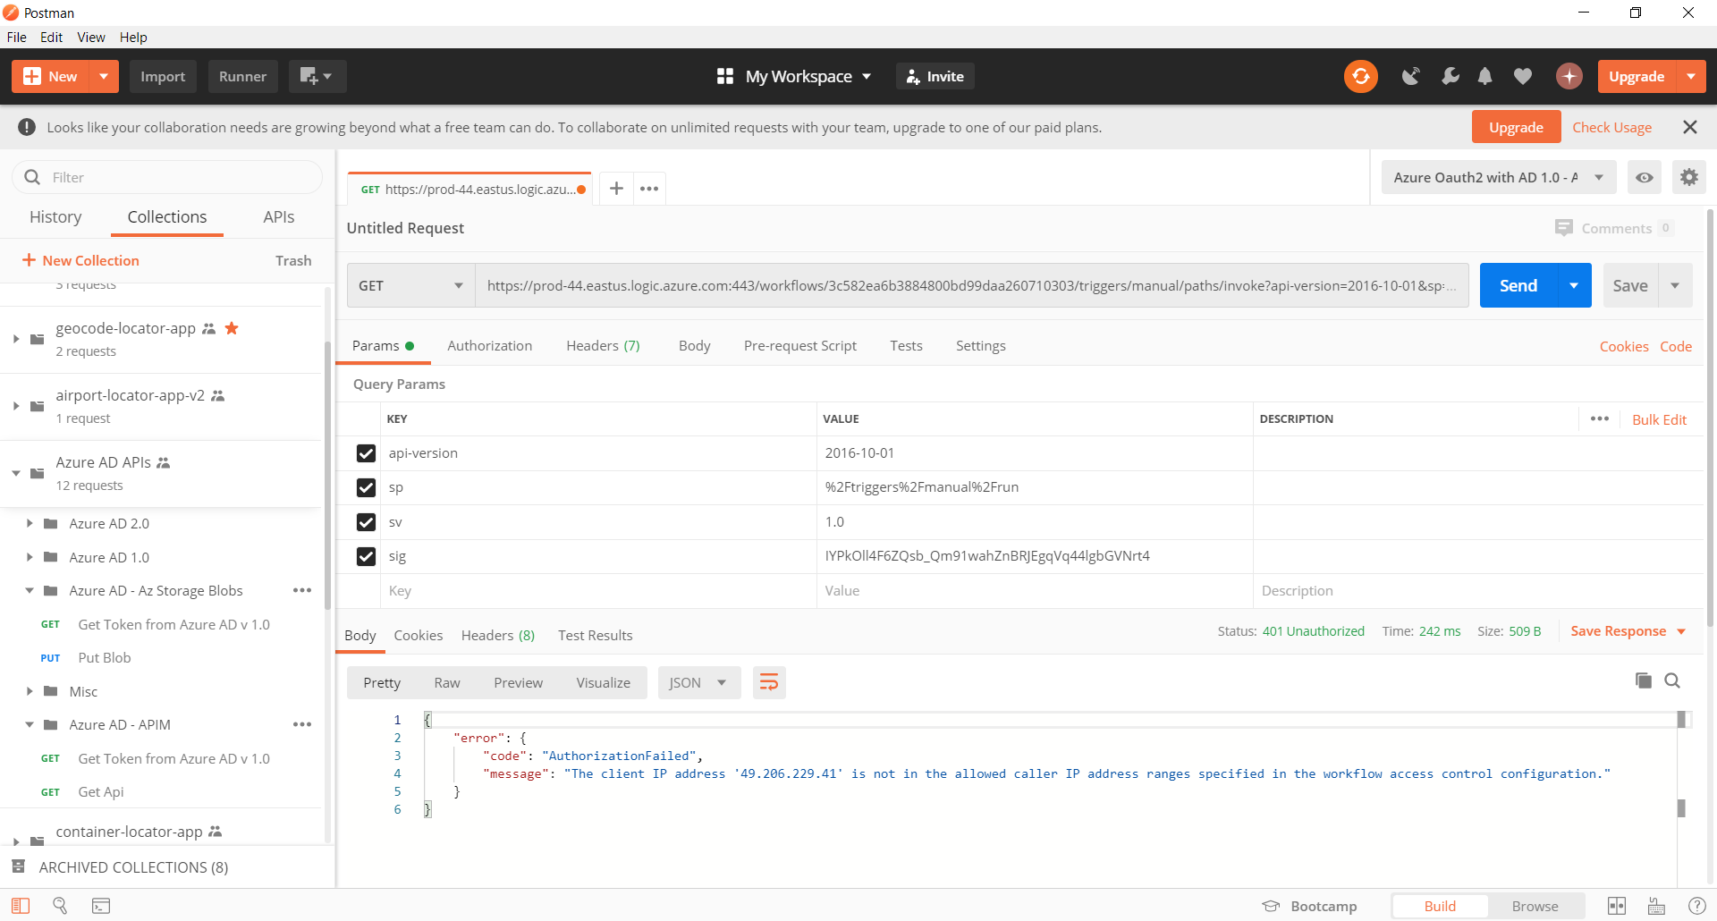

**Configure Azure API as shown**

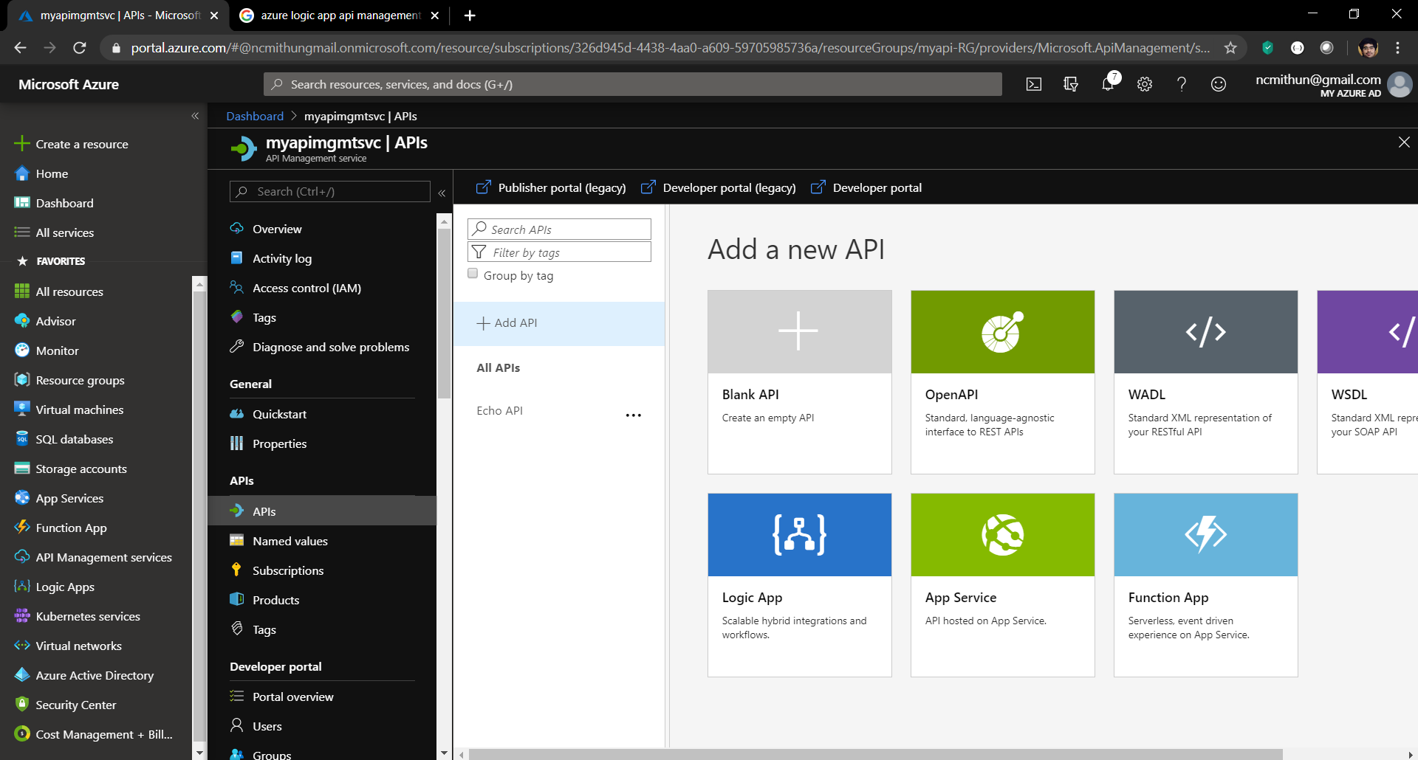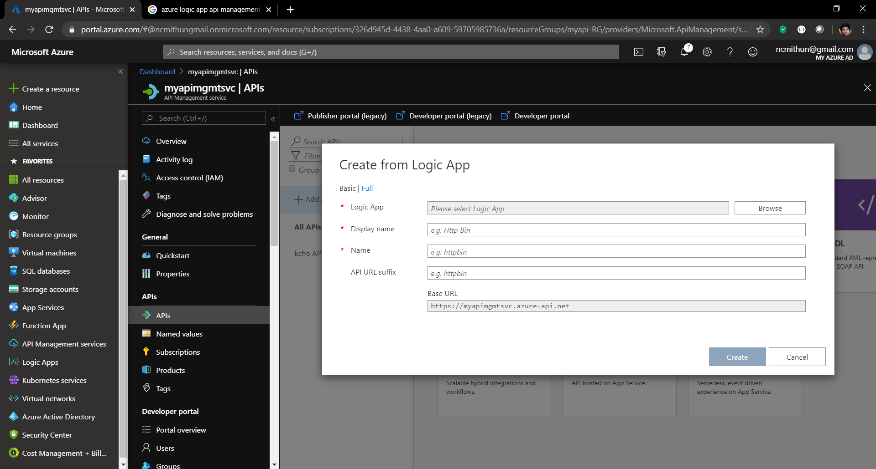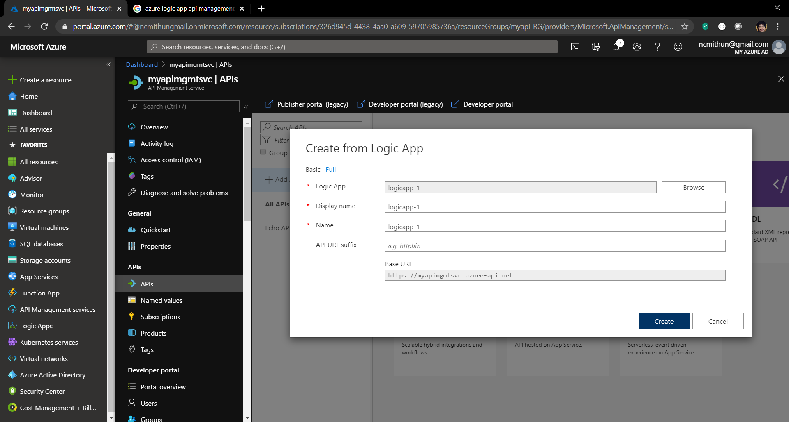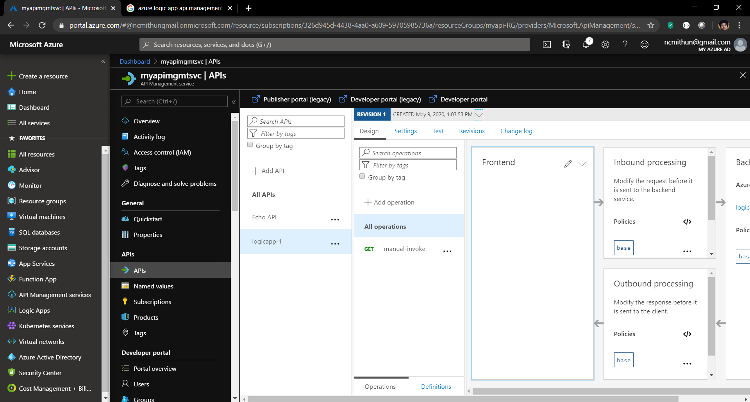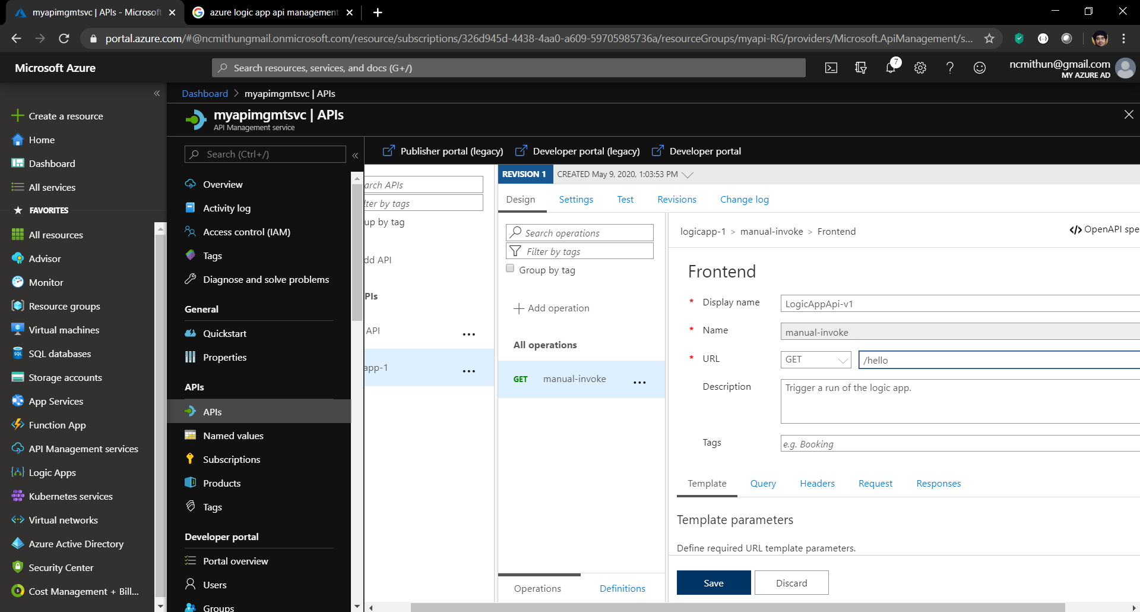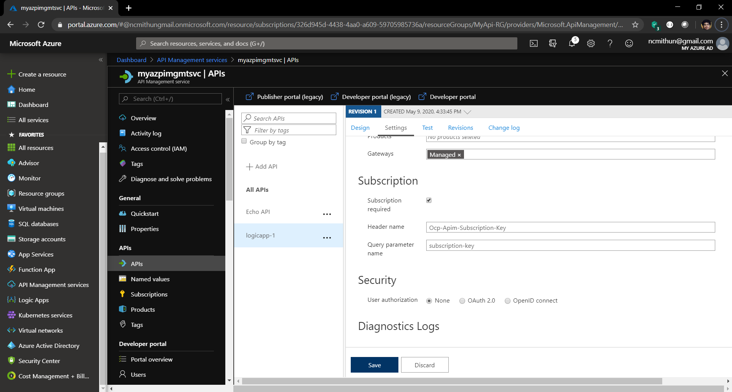

Uncheck subscription required

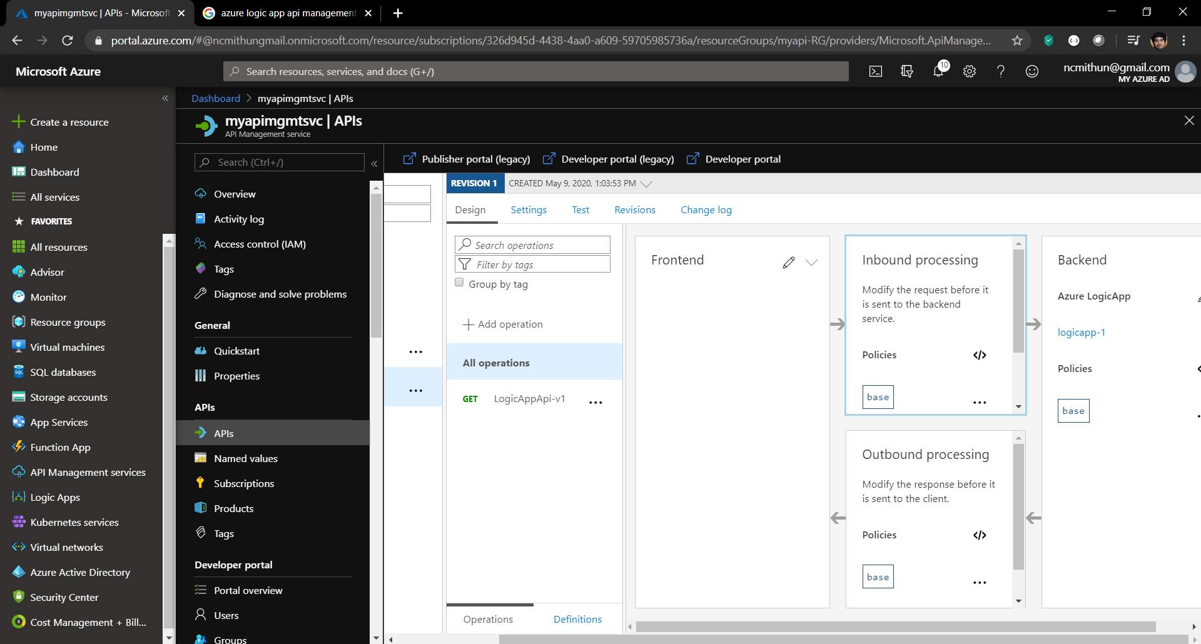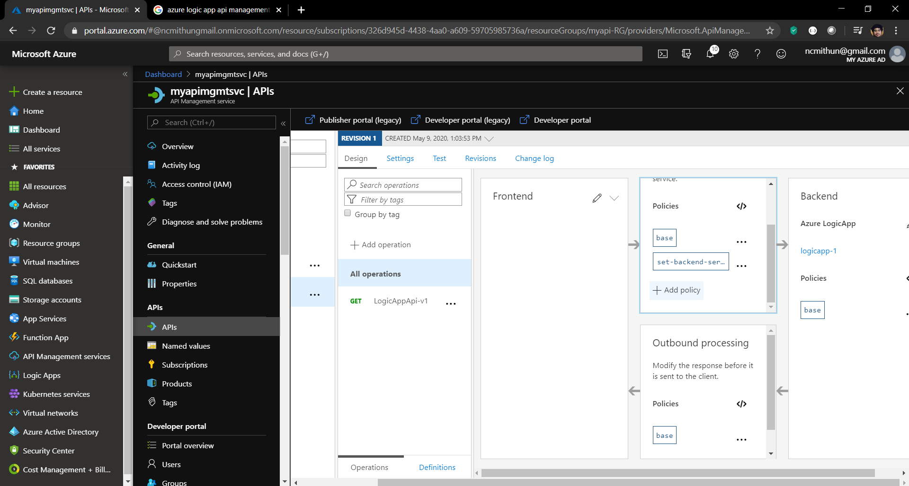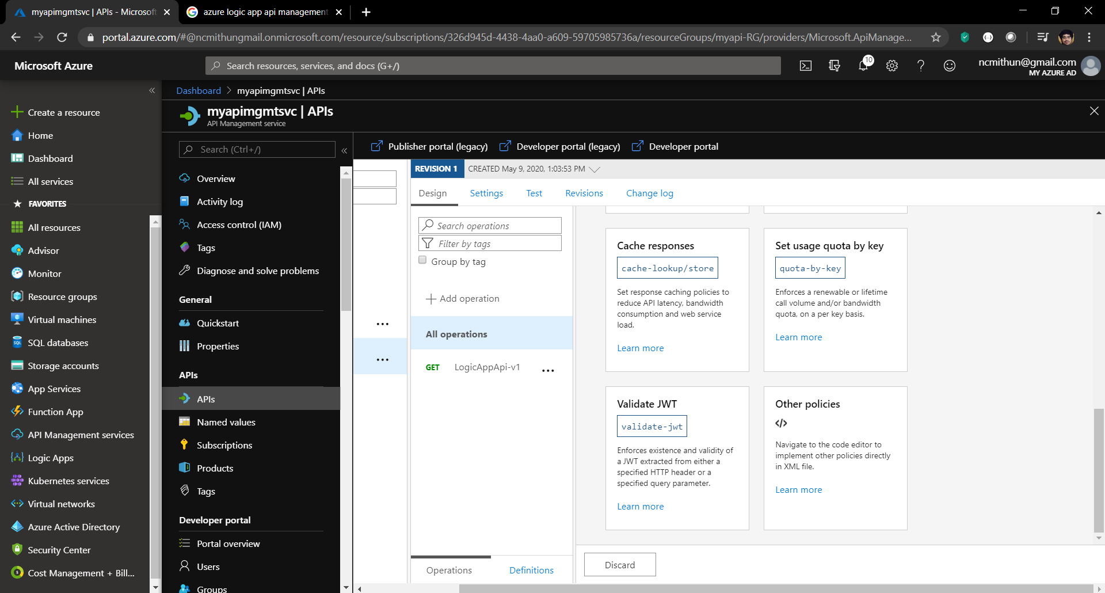

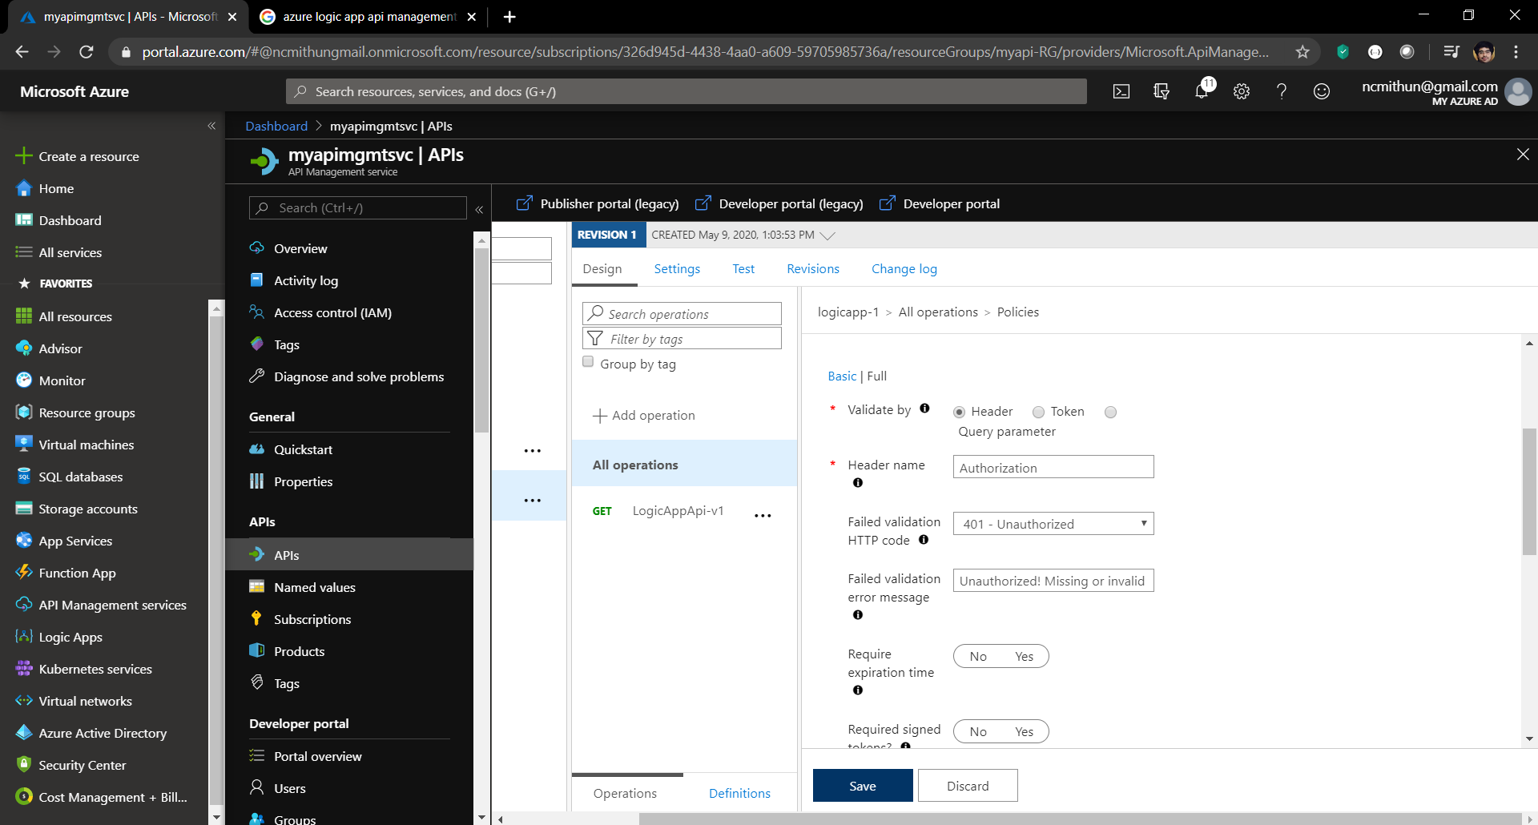

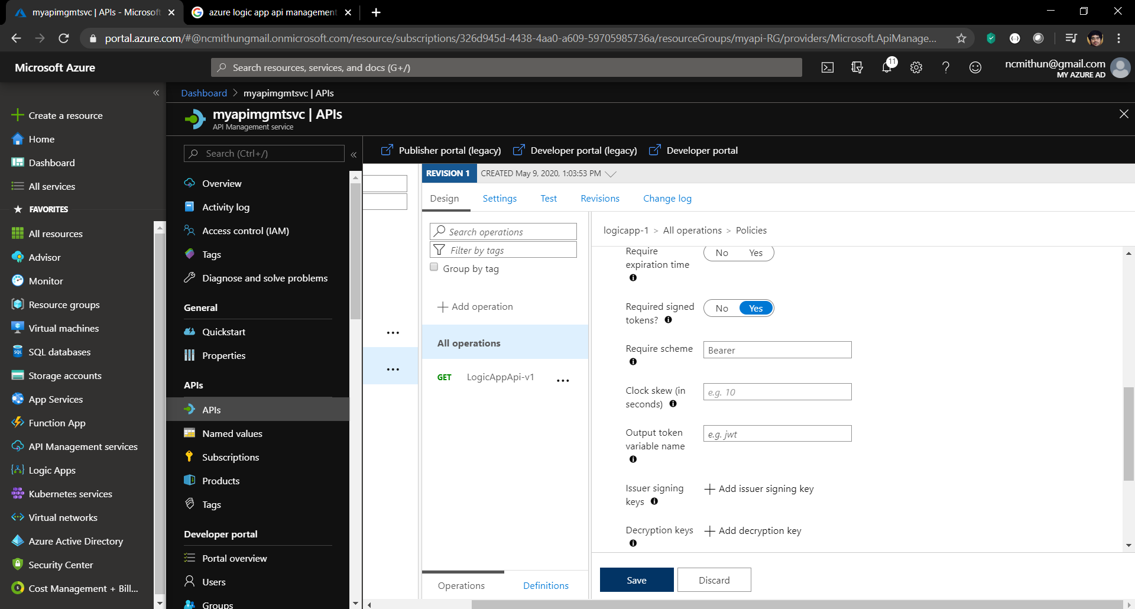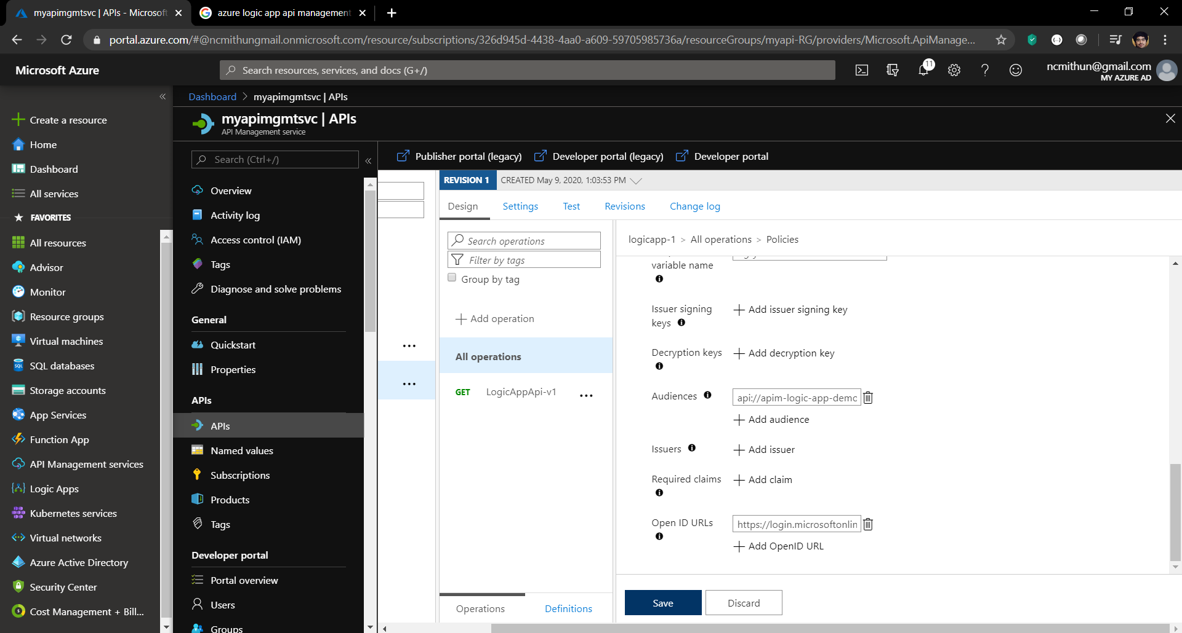

Set the following

**Validate by** - Header

**Header name** - Authorization

**Failed validation HTTP code** – 401 – Unauthorized

**Failed validation error message** - Unauthorized. Missing or invalid token.

**Required signed tokens?** - Yes

**Audiences -** api://apim-logic-app-demo (should match with **Dashboard >> Azure Active Directory >> App registrations >> <Client App> >> Expose an API >> Application ID URI** which is done later in the document)

**Require scheme -** Bearer

**Open ID URLs** - https://login.microsoftonline.com/4ea6445f-e804-4e09-96c0-4fe22644a40d/.well-known/openid-configuration (where 4ea6445f-e804-4e09-96c0-4fe22644a40d is tenant id)

**Policy code for Validate JWT**

<policies>

<inbound>

<base />

<set-backend-service id="apim-generated-policy" backend-id="LogicApp_logicapp-1_MyApi-RG_326d945d44384aa0a60959705985736a" />

<validate-jwt header-name="Authorization" failed-validation-httpcode="401" failed-validation-error-message="Unauthorized. Missing or invalid token" require-scheme="Bearer" require-signed-tokens="true">

<openid-config url="https://login.microsoftonline.com/4ea6445f-e804-4e09-96c0-4fe22644a40d/.well-known/openid-configuration" />

<audiences>

<audience>api://apim-logic-app-demo</audience>

</audiences>

</validate-jwt>

</inbound>

<backend>

<base />

</backend>

<outbound>

<base />

</outbound>

<on-error>

<base />

</on-error>

</policies>

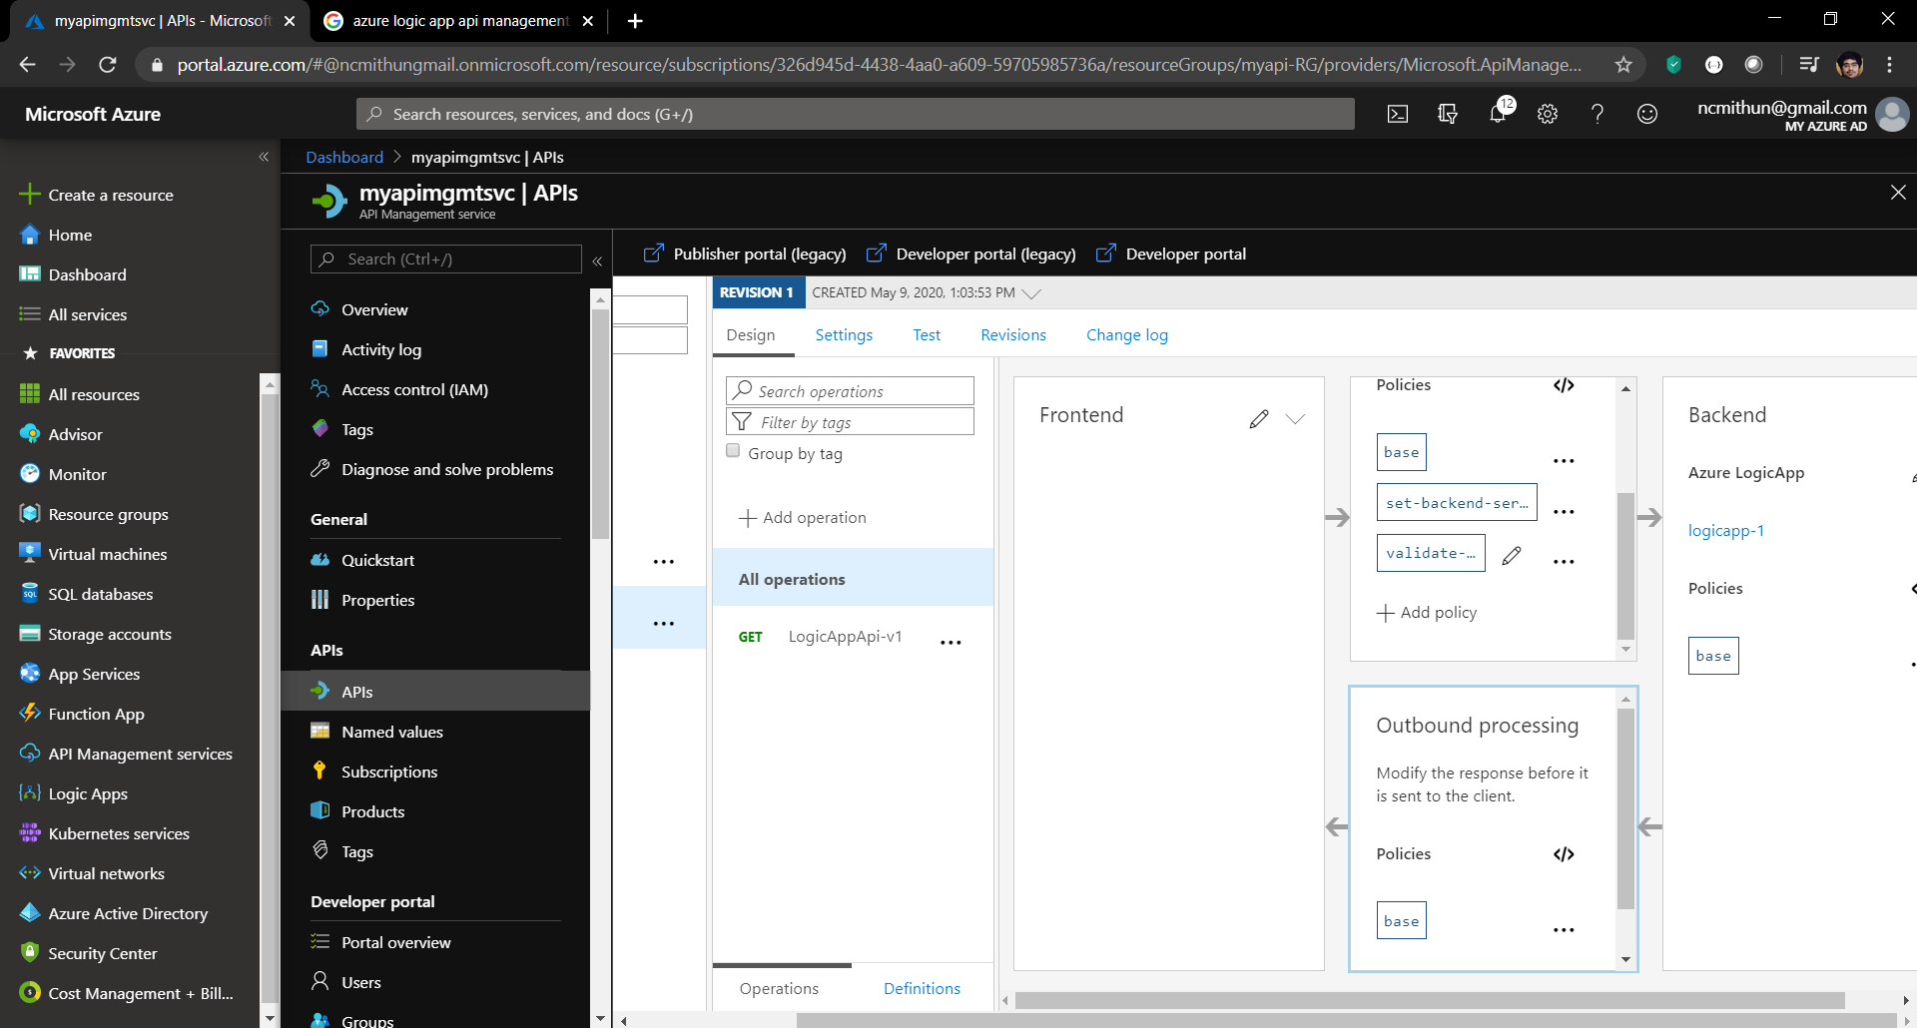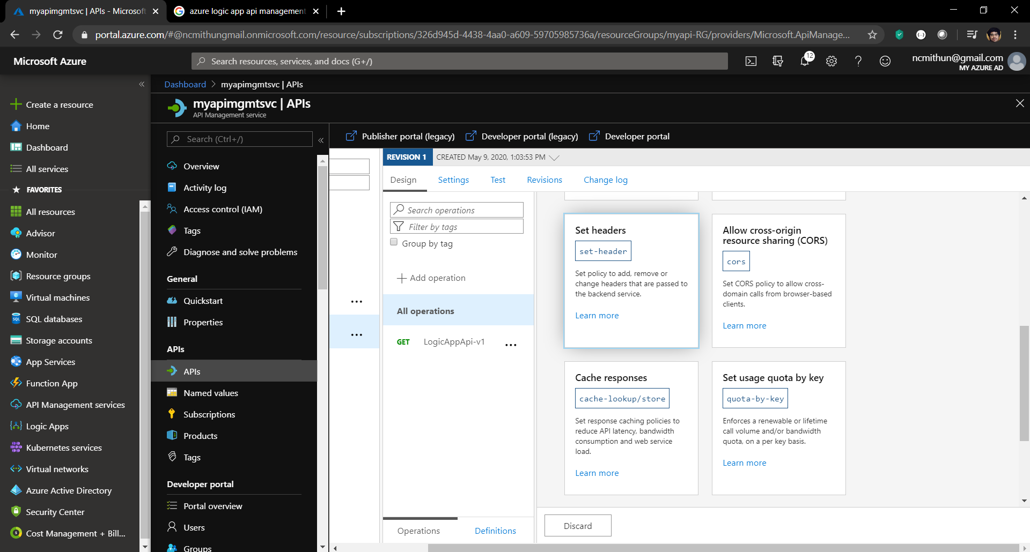

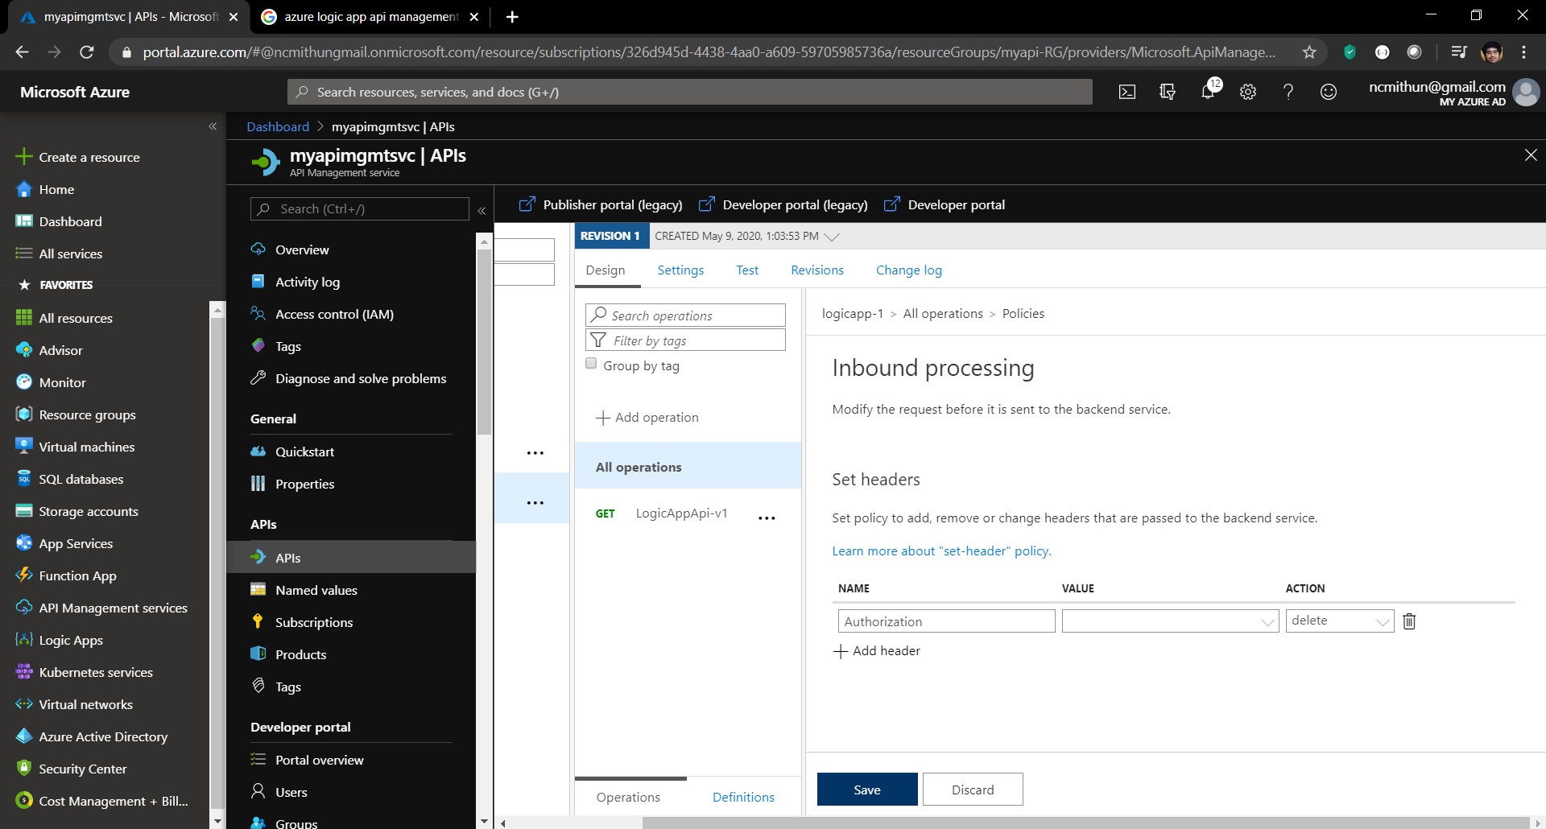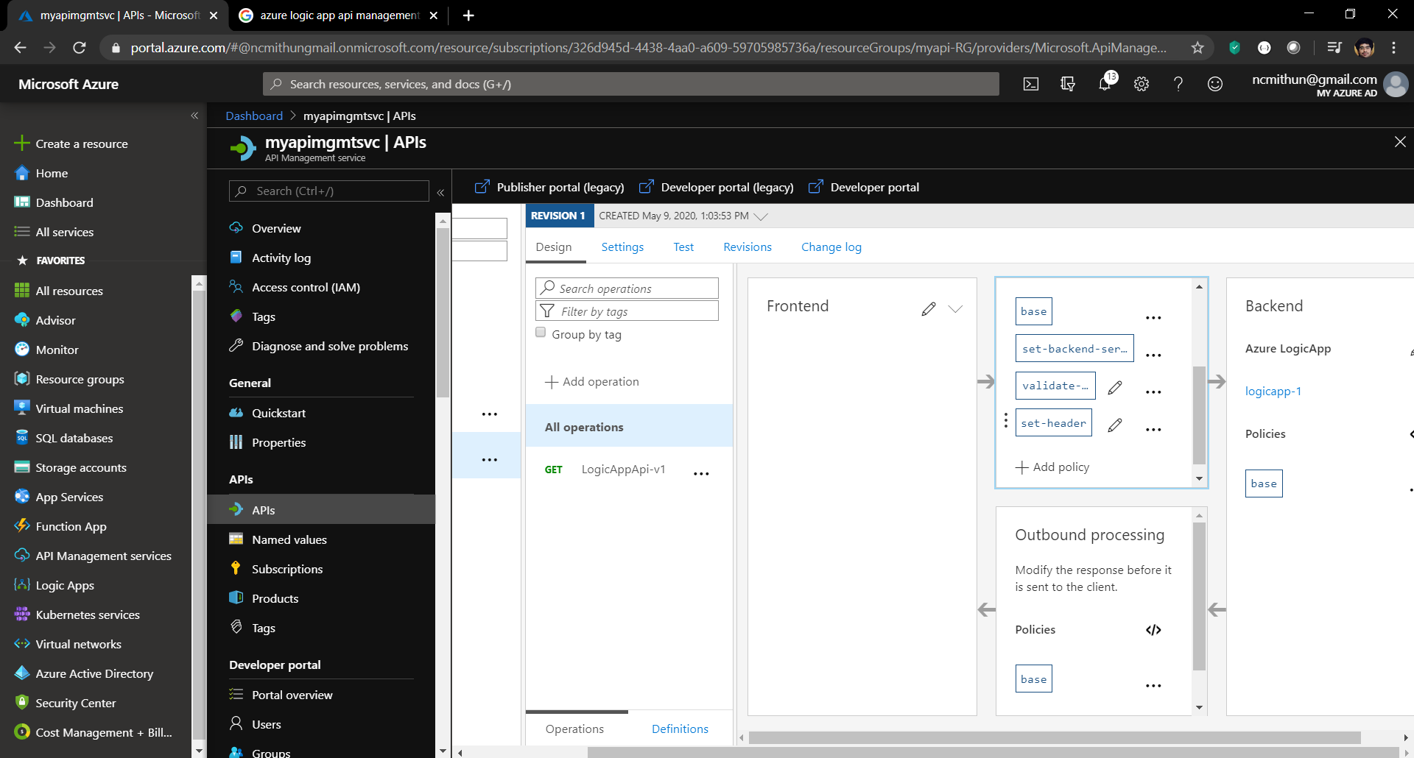

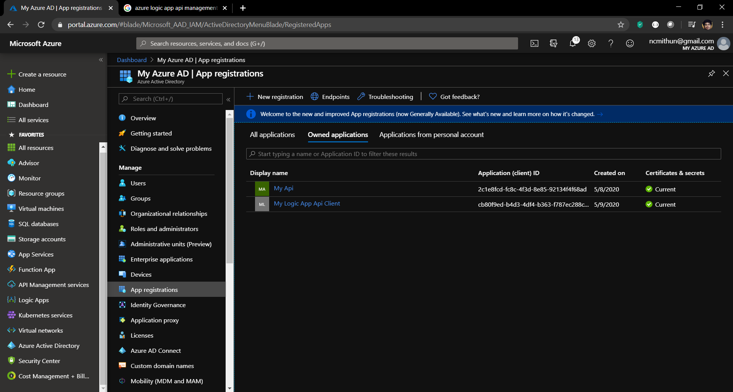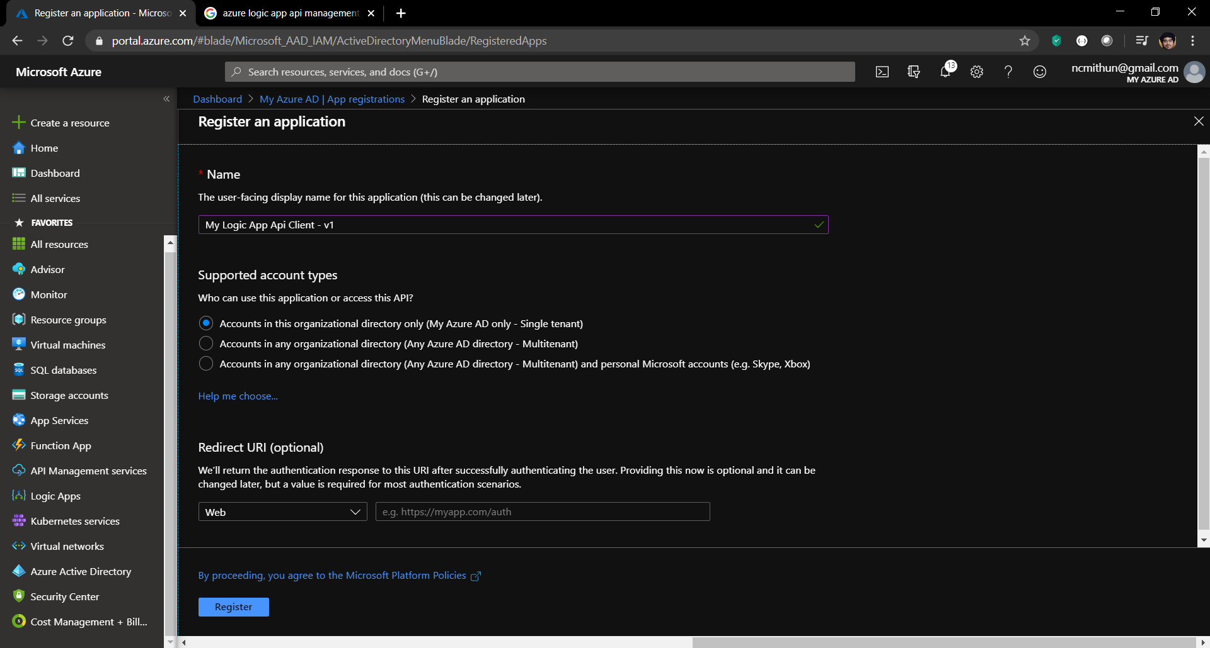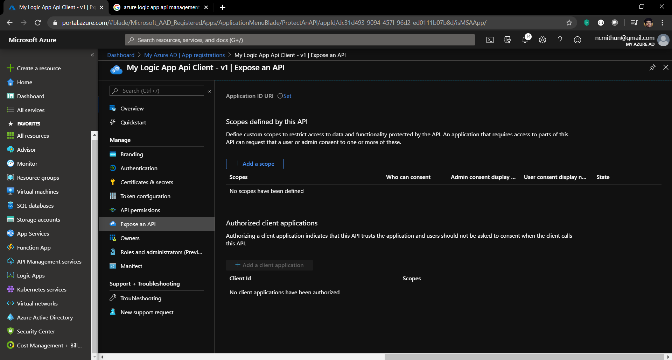 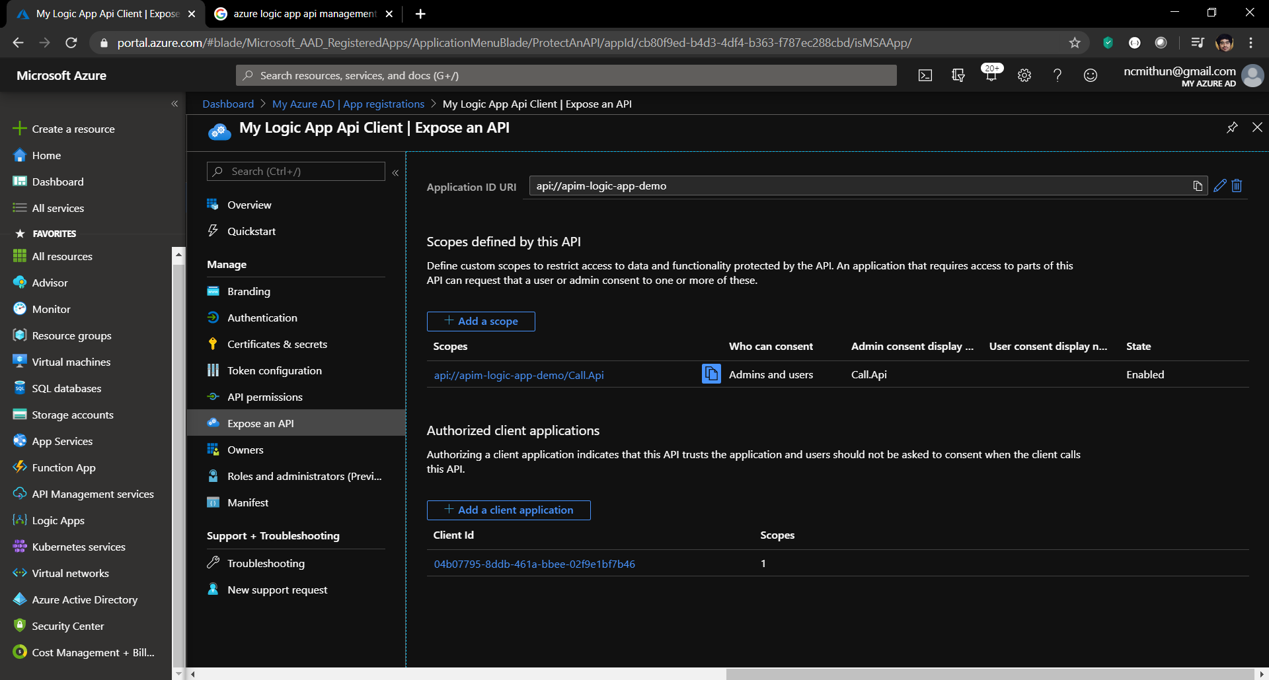

For client id, use command –

*az account get-access-token*

Parse the token using - [**https://jwt.io/**](https://jwt.io/)and look for AppId

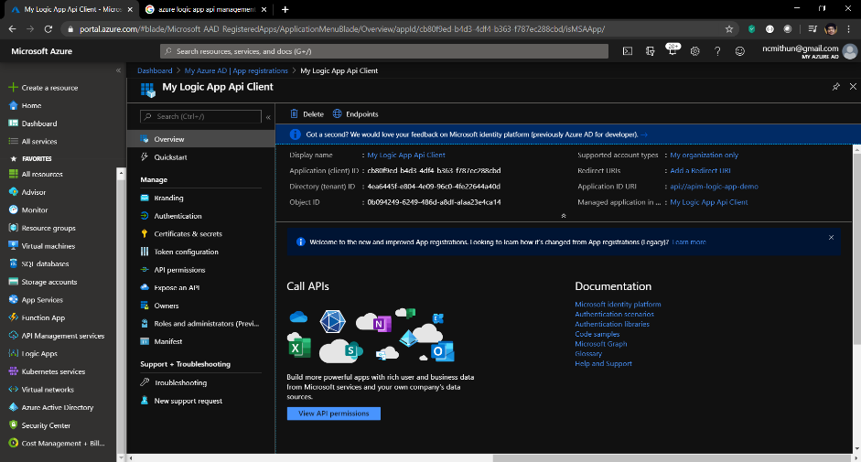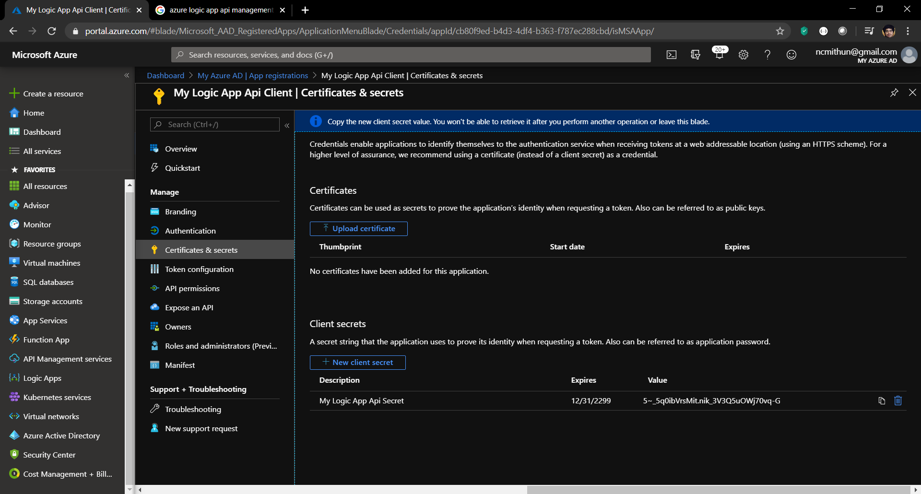

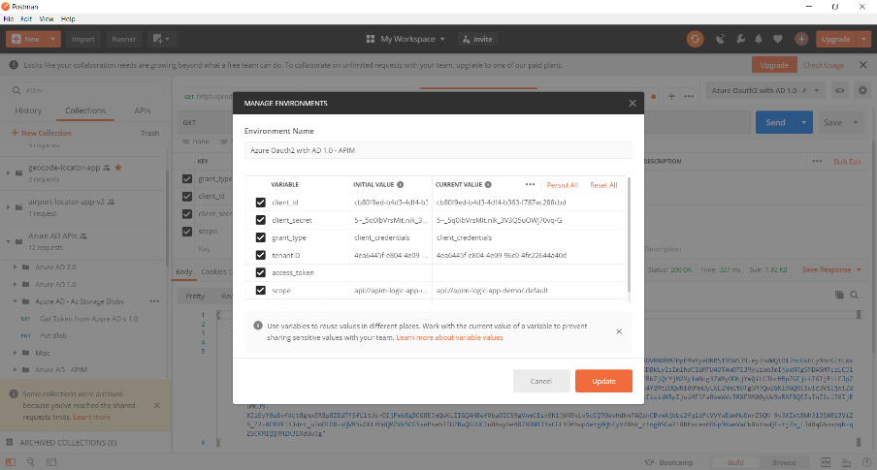

should match with **Dashboard >> Azure Active Directory >> App registrations >> <Client App> >> Expose an API >> Application ID URI**

**api://apim-logic-app-demo/.default**

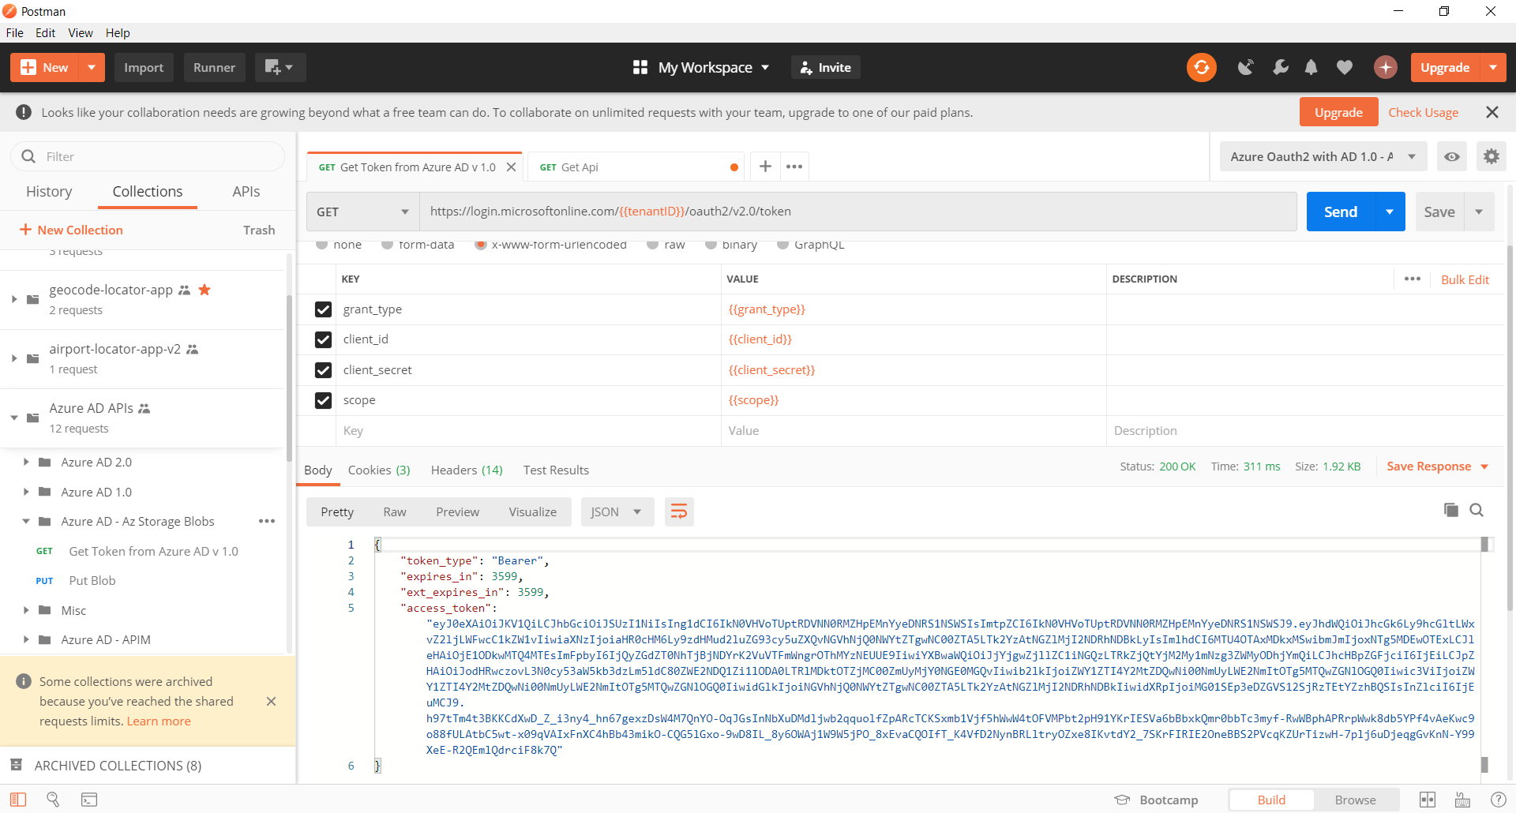

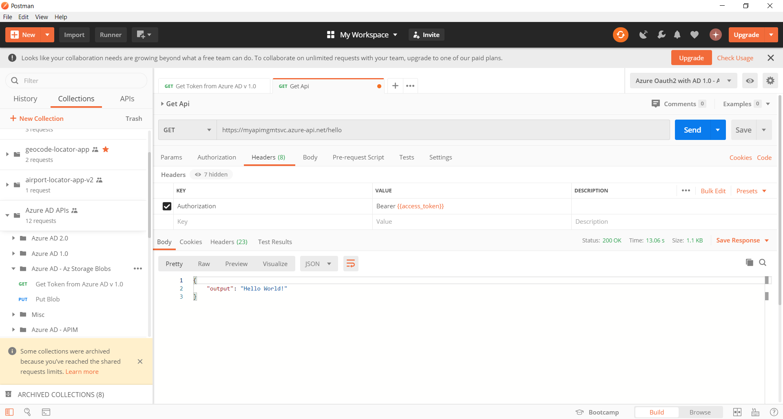

*Can also be verified from command line using –*

*az rest --uri "https://myazpimgmtsvc.azure-api.net/hello" --method GET --headers "Authorization Bearer <token>" --resource "api://apim-logic-app-demo"*